IOT BASED FLOOD MONITORING AND ALERTING SYSTEM

|  |  |  |
| --- | --- | --- |
| Siva Prakash.K | Vinitha.G | Dr.S.Malliga BE.,ME., Ph.D |
| Department of Computer Science Engineering | Department of Computer Science Engineering | Department of Computer Science Engineering |
| Kongu Engineering College, Perundurai, Erode-60 | Kongu Engineering College, Perundurai, Erode-60 | Kongu Engineering College, Perundurai, Erode-60 |
|  |  |  |

**Abstract:Flood ranks as one of the most damaging forms of natural disaster in the world. Deathrate due to flood increases because of absence of early warning. The purpose of a flood warning service is to detect and forecast threatening flood events so that the public can be alerted in advance and can undertake appropriate responses to minimize the loss. Deploying various sensors at the river side, reservoirs and in various incoming sources of water which helps in the real-time measurement and monitoring of the hydrological conditions of rivers is proposed in this work. The data from sensors are analysed and alert message is sent through SMS and also displayed in website.**

**1.INTRODUCTION**

Flood is one of the most dangerous natural disasters since they have enough destructive power to change the course of rivers, sweep away and destroy whatever is in their path. While some areas are more prone to flooding than others, the establishment of flood warning systems near any major waterway or body of water provides critical information that can protect property and save lives.

The Internet of Things (IoT) is a computing concept that describes a future where every day physical objects will be connected to the Internet and will be able to identify themselves to other devices. This is because an object that can represent itself digitally becomes something greater than when the object existed by itself. No longer does the object relate just to the user’s computer, but now it is connected to objects around it, data from a database, etc.

An embedded system is a computer system designed for specific control functions within a larger system, often with real-time computing constraints. It is embedded as part of a complete device often including hardware and mechanical parts. By contrast, a general-purpose computer, such as a personal computer (PC), is designed to be flexible and to meet a wide range of end-user needs. Embedded systems control many devices in common use today. Embedded systems contain processing cores that are mostly microcontrollers.

**2.PROPOSED MODEL**

**“IOT BASED FLOOD MONITORING AND ALERTING SYSTEM**”alerts the peoplenear the river bank area through SMS. A Raspberry pi microcontroller is used to control the whole system. It is integrated with vibration sensor, ultrasonic sensor and rainfall sensor. The rainfall sensor is used to measure the rainfall in the area of reservoir. Dam failure is predicted using vibration sensor. The distance between the ultrasonic sensor and water in the dam is measured and level of the water is calculated. The calculated water level is displayed in the web page. The data from all three sensors are analysed and alert message is sent through SMS. The fig 2.1 shows the block diagram of proposed model.

Ultrasonic sensor

Way2SMS

Raspberry

pi

Rainfall sensor

Vibration sensor

Database

**Fig 2.1** Block diagram of proposed model

**2.1Ultrasonic Sensor**

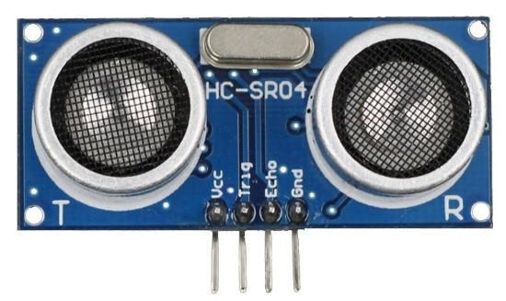

**Fig 2.2** Ultrasonic sensor

An Ultrasonic sensor is a device that can measure the distance to an object by using sound waves. It measures distance by sending out a sound wave at a specific frequency and listening for that sound wave to bounce back. By recording the elapsed time between the sound wave being generated and the sound wave bouncing back, it is possible to calculate the distance between the sonar sensor and the object. The fig 2.3 shows how the distance is measured using ultrasonic waves.

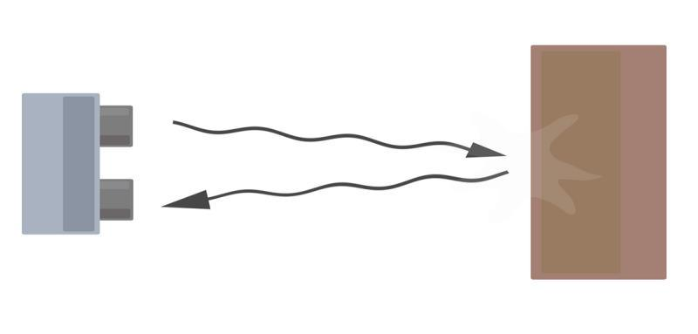

**Fig 2.3** Distance measurement

The distance calculated as shown below:

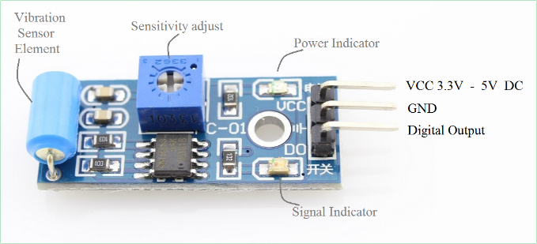Speed of sound =340m/s=0.034 cm/Ms

Time = Distance/speed.

Distance in cm=time*0.034/2

or

Distance in cm=time/29/2

Based on the distance, height of water is calculated.

**2.2Rainfall Sensor**

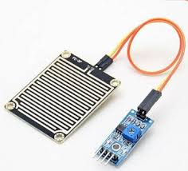

**Fig 2.4** Rainfall sensor

The rain sensor module is an easy tool for rain detection. The figure 4 shows rain sensor. It can be used as a switch when raindrop falls through the raining board and also for measuring rainfall intensity. The module features, a rain board and the control board that is separate for more convenience, power indicator LED and an adjustable sensitivity though a potentiometer [3]. The analog output in rainfall sensor helps to detect the amount of rainfall in the area of the reservoir. One of the hydrological conditions, rain is monitored using rain sensor.

**2.3Vibration Sensor**

The vibration sensor module produce logic states depends on vibration and external force applied on it. When there is no vibration this module gives logic low output.

**Fig 2.5** Vibration sensor

When it feels vibration then output of this module goes to logic high [4]. When the dam starts cracking it produces vibrations which will be detected by the vibration sensor and sends alert message and also display an alert in webpage.

**2.4SMS**

Way2SMS is very simple and easy to use and allows users to send free SMS to any mobile network in India[2]. The reliability of Way2SMS in delivering messages instantly is not 100% but 95% of messages will be delivered in less than 10 seconds. We use this application to send alerts and notifications to the numbers registered in the database.

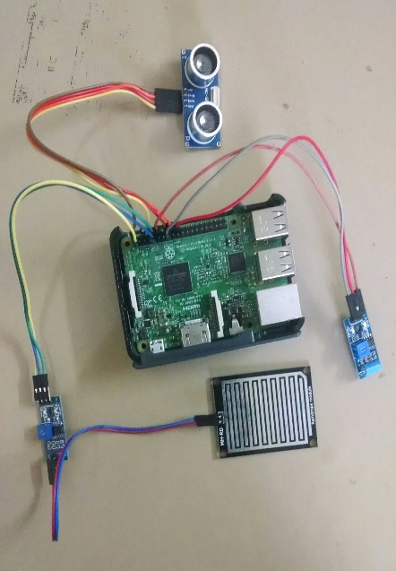**3. CONNECTION DIAGRAM**

**Fig 3.1** Connection Diagram

**4. CONCLUSION**

This project aims at monitoring the dam condition and predicts the occurrence of flood. By doing so we can reduce the man power needed for doing this process and also can save many lives at the most crucial time. This can be implemented for all the dams near agricultural lands which can very much helpful for the farmers.

**REFERENCES**

[1]http://education.rec.ri.cmu.edu/content/electronics/boe/ultrasonic_sensor/1.html

[2]http://site21.way2sms.com/content/index.html?

[3]https://www.openhacks.com/uploadsproductos/rain_sensor_module.pdf

[4]https://5.imimg.com/data5/DV/NE/MY-1833510/vibration-sensor.pdf